EXPT NO: 7 | TEXT PREPROCESSING AND EMBEDDING GENERATION USING NLP LIBRARIES
DATE: 12/10/2026

PRE-LAB QUESTIONS (PROVIDE BRIEF ANSWERS TO THE FOLLOWING QUESTIONS)

Name: Midhun P Roll No: 24BAD069

Git Hub Link:

- Explain the importance of text preprocessing in Natural Language Processing.

Text preprocessing cleans and organizes raw text before it is given to an NLP model. It removes unnecessary symbols and standardizes words for consistent analysis. Tokenization divides text into smaller units such as words. Stop-word removal and lemmatization can reduce noise and word-form variations. Good preprocessing can improve efficiency and the quality of language analysis.

- Differentiate between tokenization, stemming and lemmatization.

Tokenization splits a sentence into individual words or tokens. Stemming cuts word endings using simple rules and may produce incomplete words. For example, stemming may reduce “studies” to “studi”. Lemmatization uses vocabulary and linguistic rules to find a valid base form. For example, lemmatization can convert “studies” to “study”.

- Explain the purpose of stop-word removal in text preprocessing.

Stop-word removal eliminates common words such as “the”, “is”, and “and”. These words often carry limited topic-specific information in many tasks. Removing them can reduce the number of tokens that must be processed. It can make important words more noticeable during frequency analysis. However, stop words should be retained when they are important to the task or meaning.

- Describe word embeddings and their significance in deep learning.

Word embeddings represent words as dense numerical vectors. Words used in similar contexts tend to have vectors with related directions. They allow machine-learning models to process text numerically. Embeddings can capture semantic and contextual relationships between words. They are useful in tasks such as text classification, search, and language modeling.

- Explain how Word2Vec represents words as dense numerical vectors.

Word2Vec learns a vector representation for each word from its surrounding context. It trains a neural-network-based model using CBOW or Skip-gram. The Skip-gram method predicts context words from a target word. Words appearing in similar contexts can receive similar vector representations. These dense vectors can be compared using measures such as cosine similarity.

AIM
To perform text preprocessing using NLTK and generate word embeddings using Gensim Word2Vec to analyze semantic relationships between words.

SOFTWARE REQUIREMENTS
- Python
- NLTK
- Gensim
- NumPy
- Google Colab
- GitHub

OBJECTIVES
Students will be able to:
- Understand the architecture and working of Recurrent Neural Networks (RNNs).
- Perform text preprocessing techniques for sequence modeling.
- Generate input sequences suitable for training an RNN model.
- Build and train an RNN model for text generation.
- Generate text by predicting the next word in a sequence.
- Evaluate the performance of the trained RNN using generated text.
- Analyze the effectiveness of RNNs in learning sequential patterns from textual data.

PROCEDURE
PART A: DATASET PREPARATION AND TEXT PREPROCESSING
Perform the following tasks:
- Load the Brown Corpus available in NLTK and select a suitable text category.
- Examine sample sentences from the selected dataset.
- Convert the text into lowercase.
- Perform word tokenization using NLTK.
- Remove punctuation and stop words.
- Perform lemmatization using WordNetLemmatizer.
- Display the original and preprocessed text.

(CODE: CONATAINS STUDENT ROLL NOS
SCREENSHOT OF CODE
SCREENSHOT OF OUTPUT)
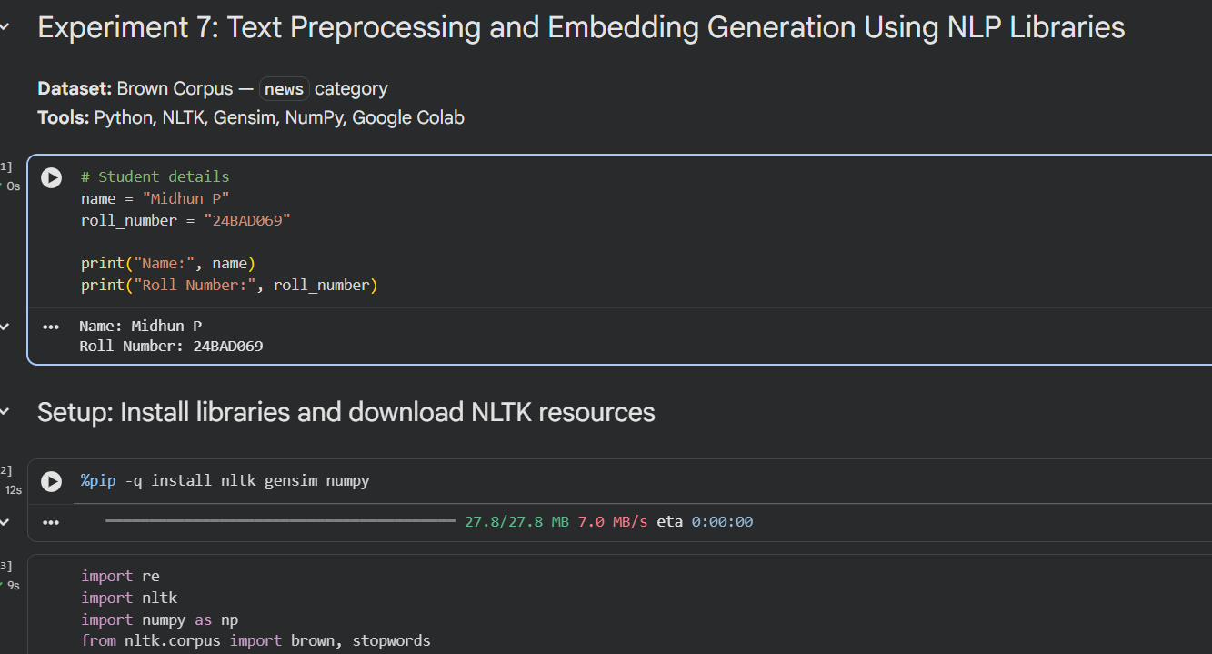
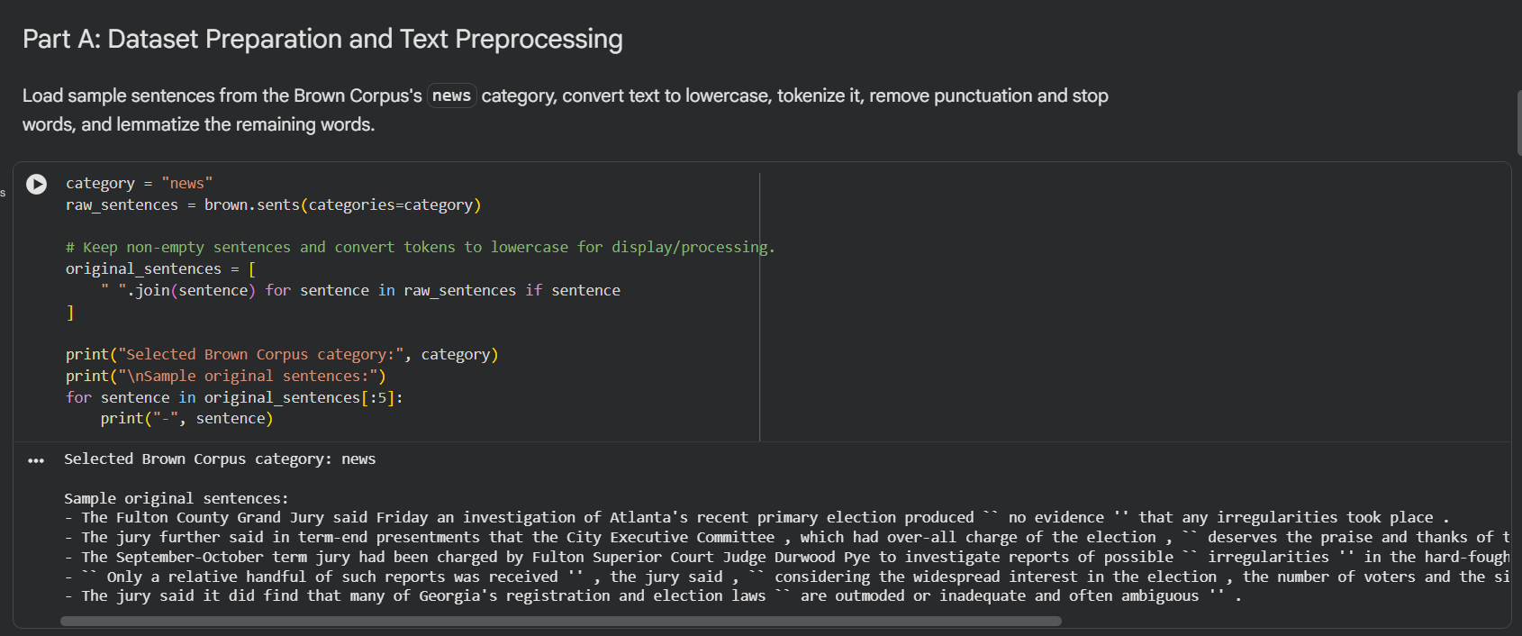
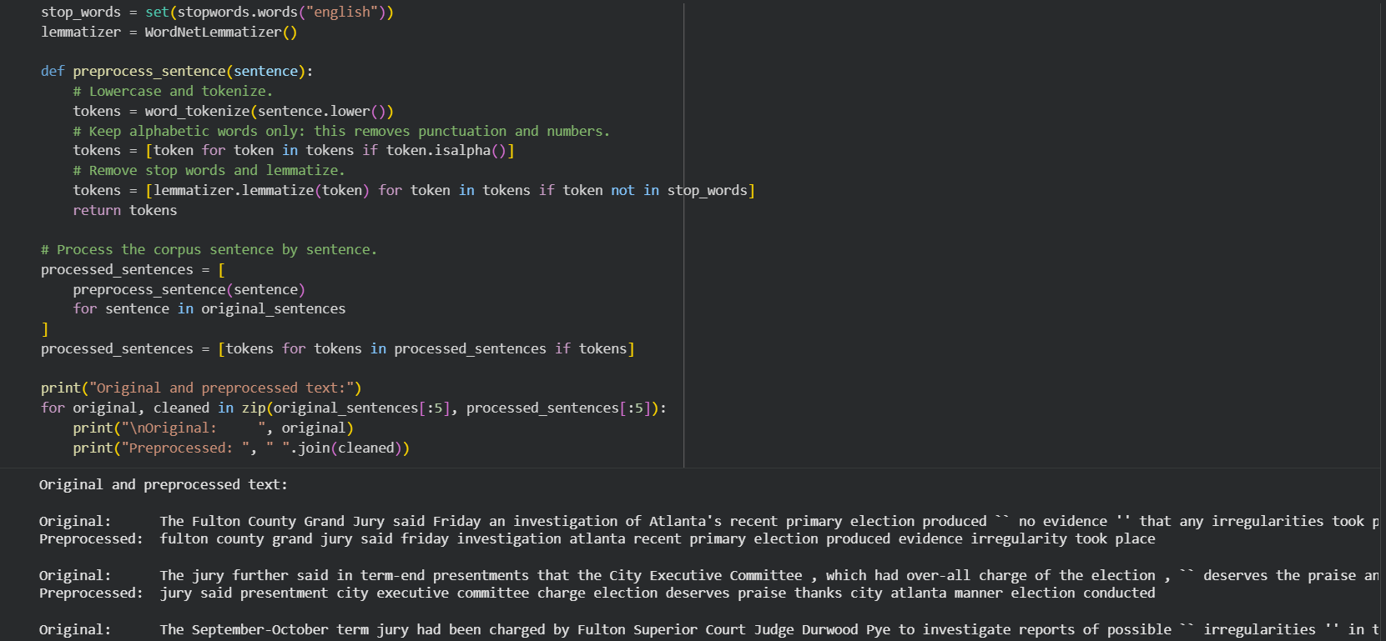

PART B: VOCABULARY GENERATION AND WORD FREQUENCY ANALYSIS
Perform the following tasks:
- Create a vocabulary from the preprocessed text.
- Calculate word frequencies using NLTK's FreqDist.
- Identify the ten most frequently occurring words.
- Display the vocabulary size and frequency distribution.
- Prepare the tokenized sentences for Word2Vec training.

(CODE: CONATAINS STUDENT ROLL NOS
SCREENSHOT OF CODE
SCREENSHOT OF OUTPUT)
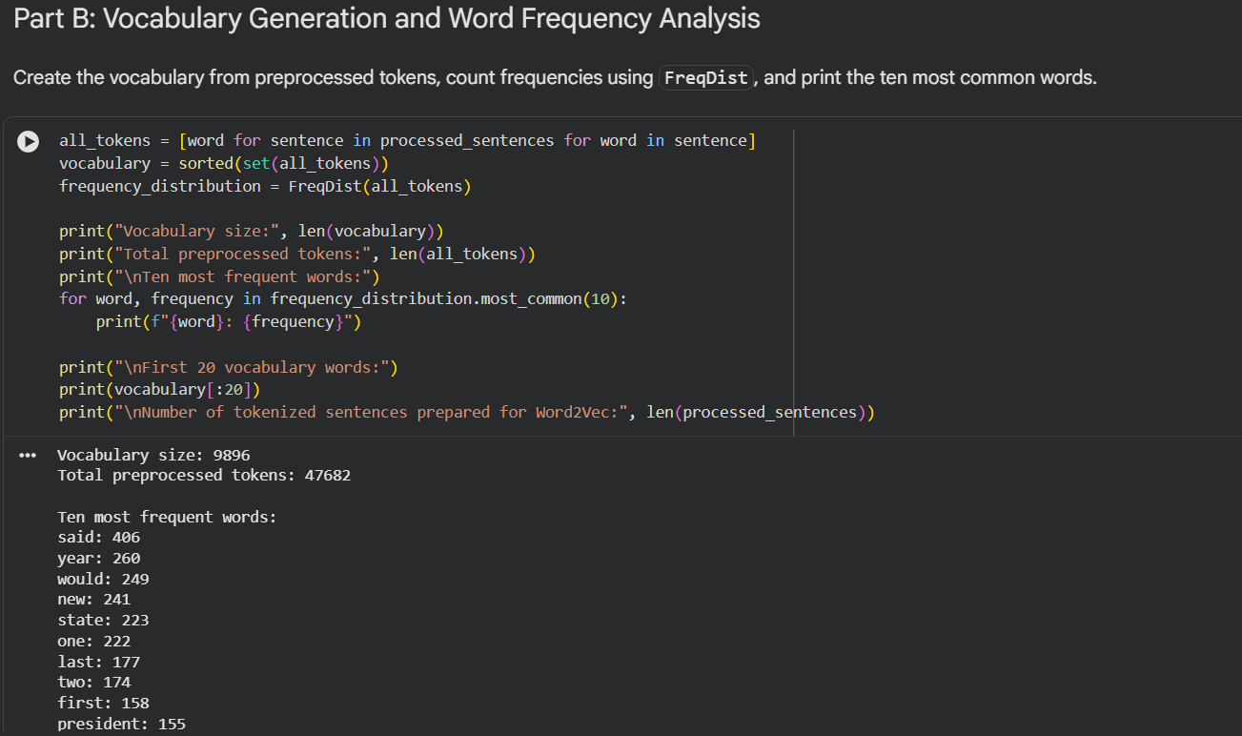

PART C: WORD EMBEDDING GENERATION USING WORD2VEC
Perform the following tasks:
- Train a Word2Vec model using Gensim on the preprocessed sentences.
- Use the Skip-gram architecture with an embedding dimension of 100 and a context-window size of 5.
- Generate embedding vectors for selected words.
- Display the embedding vector and its dimensions.
- Identify the five most similar words for a selected word using the trained model.

(CODE: CONATAINS STUDENT ROLL NOS
SCREENSHOT OF CODE
SCREENSHOT OF OUTPUT)

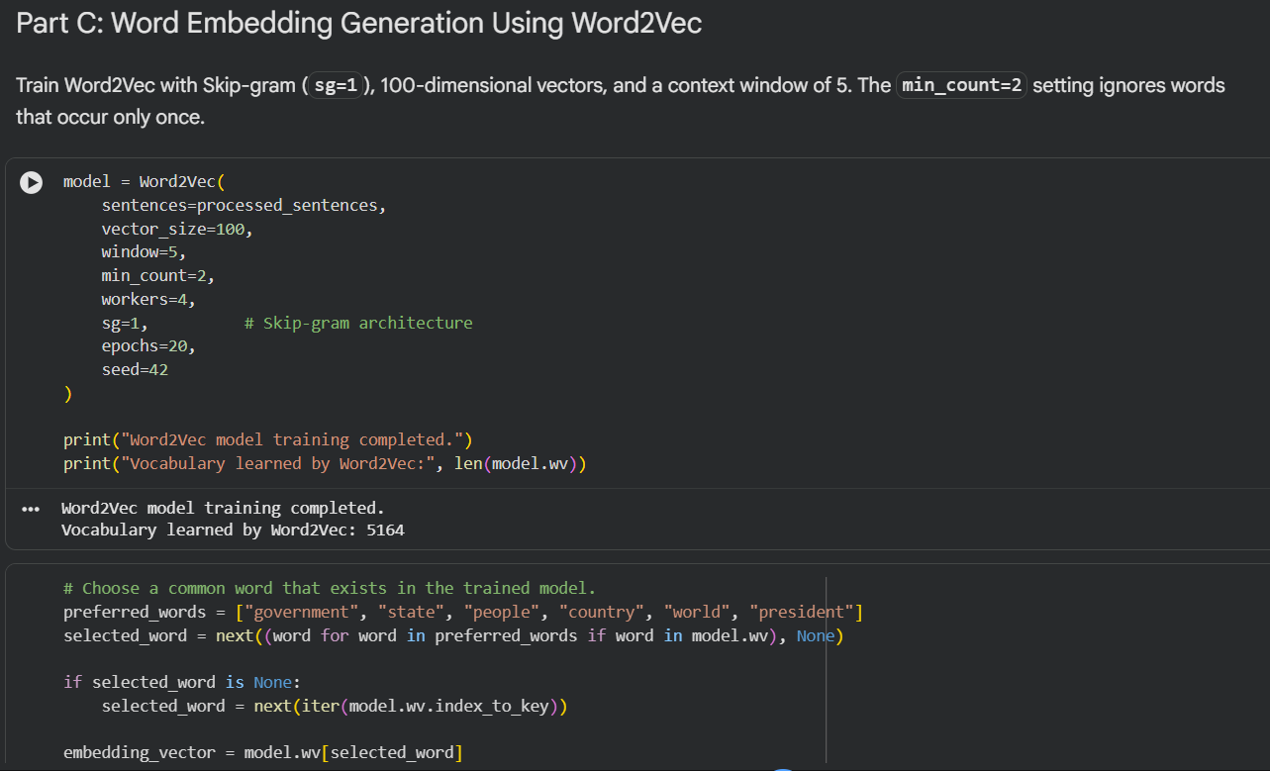
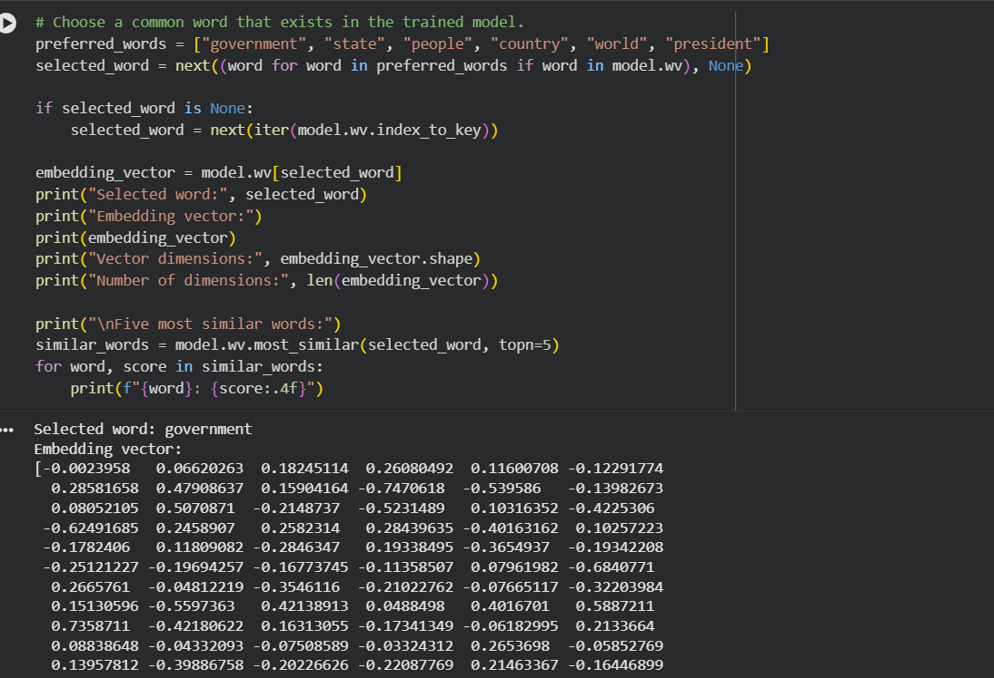

PART D: WORD SIMILARITY ANALYSIS AND EXPERIMENT MANAGEMENT
Perform the following tasks:
- Select three meaningful word pairs from the trained vocabulary.
- Calculate the cosine similarity between each pair using the Word2Vec model.
- Compare the similarity scores and identify the most similar pair.
- Analyze the relationship between contextual similarity and the generated word embeddings.
- Document the observations and upload the completed notebook to GitHub.

(CODE: CONATAINS STUDENT ROLL NOS
SCREENSHOT OF CODE
SCREENSHOT OF OUTPUT)
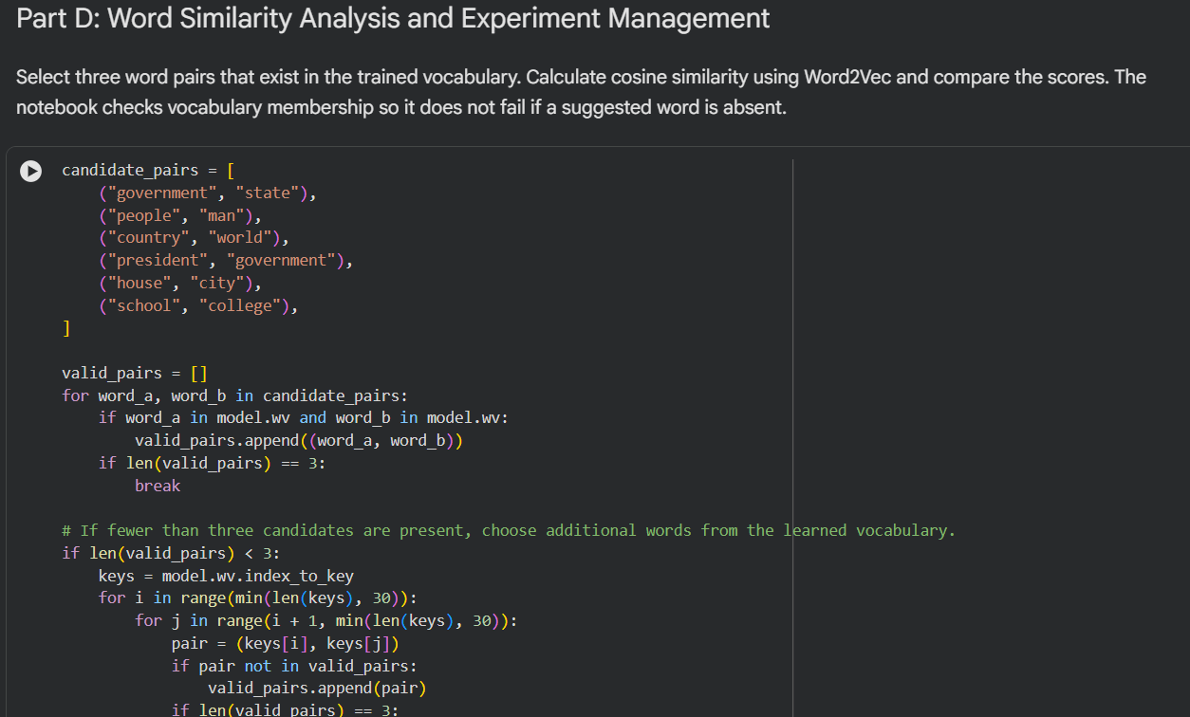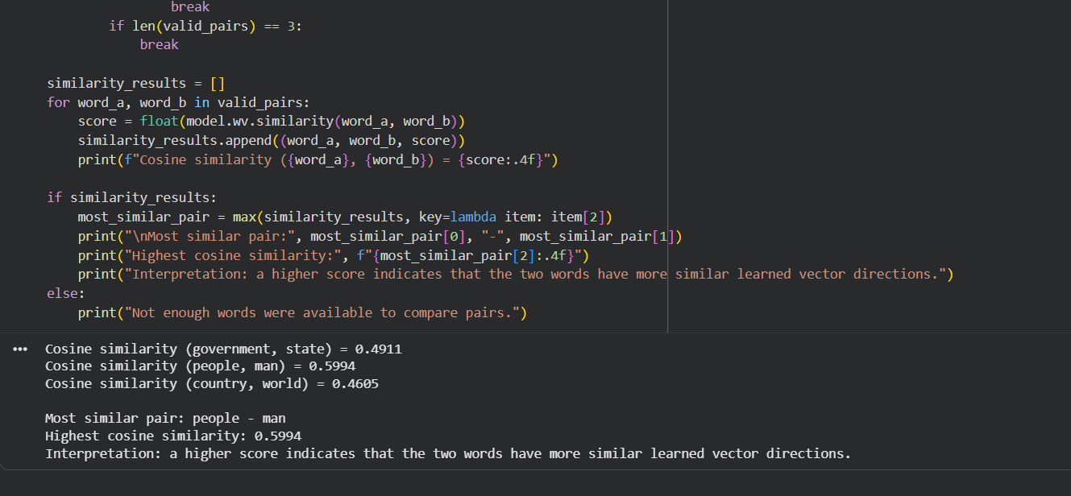

POST-LAB QUESTIONS (PROVIDE BRIEF ANSWERS TO THE FOLLOWING QUESTIONS)

- Analyze the effect of stop-word removal and lemmatization on the quality of preprocessed text.

Stop-word removal reduces common words that may contribute little to the task. This can reduce text size and help emphasize informative terms. Lemmatization converts related word forms to a common base form. For example, “cars” may become “car”, reducing unnecessary vocabulary variation. Over-removal or incorrect lemmatization can lose meaning, so preprocessing should suit the task.

- Explain how vocabulary size influences Word2Vec training.

Vocabulary size is the number of unique words considered by Word2Vec. A larger vocabulary may represent more terms but requires more memory and training time. Rare words may have too few examples for reliable embeddings. The min_count parameter removes words occurring fewer than a chosen number of times. A suitable vocabulary balances coverage, training cost, and embedding quality.

- Compare the CBOW and Skip-gram architectures of Word2Vec.

CBOW predicts a target word from the surrounding context words. Skip-gram predicts surrounding context words from a target word. CBOW is generally faster and can work well for frequent words. Skip-gram can learn useful representations for less frequent words when enough data is available. Both methods learn word vectors from context, but their prediction tasks differ.

- Analyze how the context-window size affects the generated word embeddings.

A small context window focuses on nearby words and local relationships. A larger window includes more distant words and may capture broader topical relationships. Larger windows can increase training work and include less directly related words. The best window size depends on the corpus and the intended NLP task. In this experiment, a window size of 5 considers up to five context positions on either side, where available.

- Interpret the cosine similarity scores obtained for the selected word pairs.

Cosine similarity measures the angle-based similarity between two word vectors. A score closer to 1 indicates that the vectors point in similar directions. A score near 0 indicates little directional similarity, while a negative score indicates opposing directions. The pair with the highest score among the selected pairs is the most similar in this model. Scores reflect patterns learned from this corpus and do not always mean the words are synonyms.

ASSESSMENT
Description | Max Marks | Marks Awarded
Pre Lab Exercise | 5
In Lab Exercise | 10
Post Lab Exercise | 5
Viva | 10
Total | 30
Faculty Signature

